**Introduction:**

Postman is an API Client and it is use to develop, test and share APIs.

**Installations:**

Signup on Postman and download Postman from <https://www.postman.com/downloads/>. You can also add Postman Chrome extension into your Chrome browser, by going to Chrome Web Store, and search for “Postman Interceptor” and add into chrome extension.

**HTTP Methods:**

* Get: Request to read a web page.
* Head: Request to read a web page header only.
* Put: Request to store a web page.
* Post: Request to append or create.
* Delete: Request to remove a web page.
* Trace: Echo the incoming request.
* Connect: Reserved for future request (No implementation now)
* Options: Query certain options.

**HTTP Status Codes:**

* 1xx: Information messages
* 2xx: Successful
* 3xx: Redirection
* 4xx: Client error
* 5xx: Server error

**Basic Get Request:**

There is a fake request and data creation web site, which also given responses for GET, POST, PUT & DELETE supported, <https://reqres.in/>.

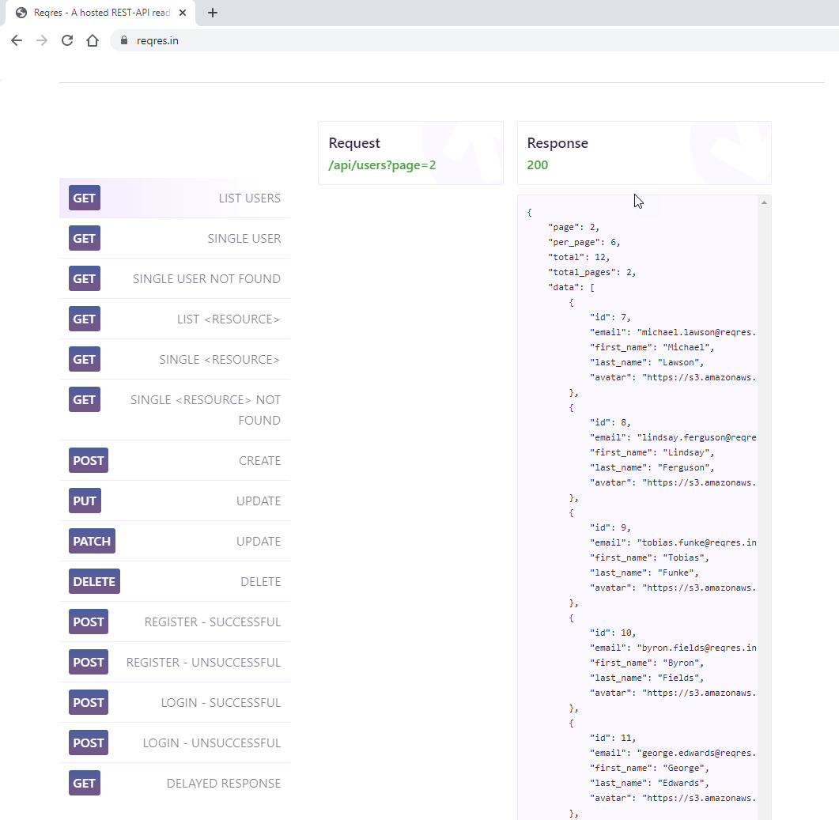

As we are discussing about GET Request, so scroll down and go for any get request, let’s take GET Request for single user, click on it and you will have its request, response and body. Copy URL <https://reqres.in/> for resreq as well as ‘Request’ of GET Request, which is [/api/users/2](https://reqres.in/api/users/2)**. Now paste it as a whole i.e.,** <https://reqres.in/api/users?page=2> in request filed of Postman and click Send button, you will have the GET Request result below.

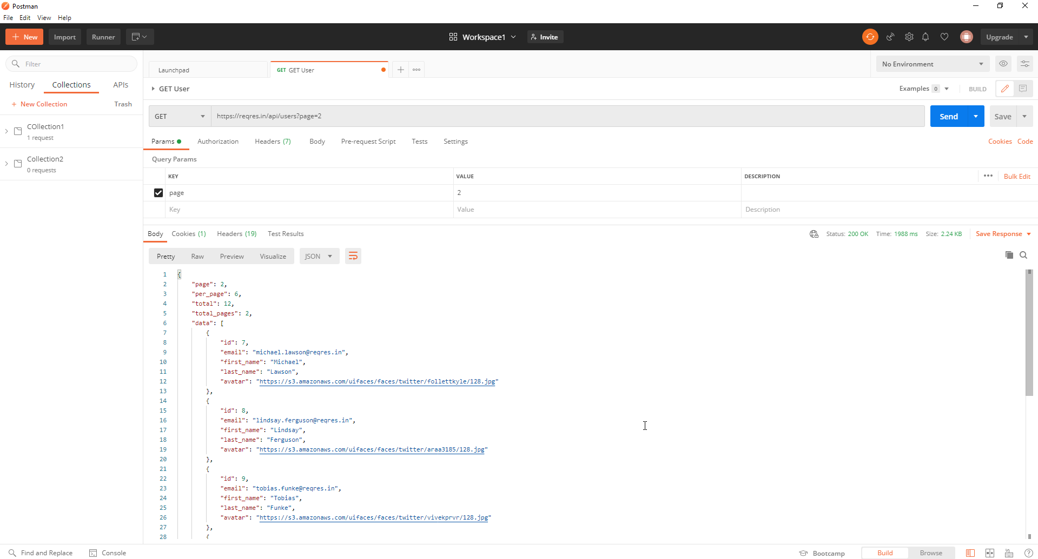

**Collection:**

Collection is a group of API request, where the API request can be store and save in logical arrangement.

**How to create a Collection:**

To create collection there are various methods, one of those, go to  button, and choose “Collection”. After that, a dialogue box will open asking name of collection, you need to enter Collection name. Under name filed, there are few more options, description, authorization, pre-request script, tests and variables. We will discuss about it later, for now after entering name, you can proceed and click create.

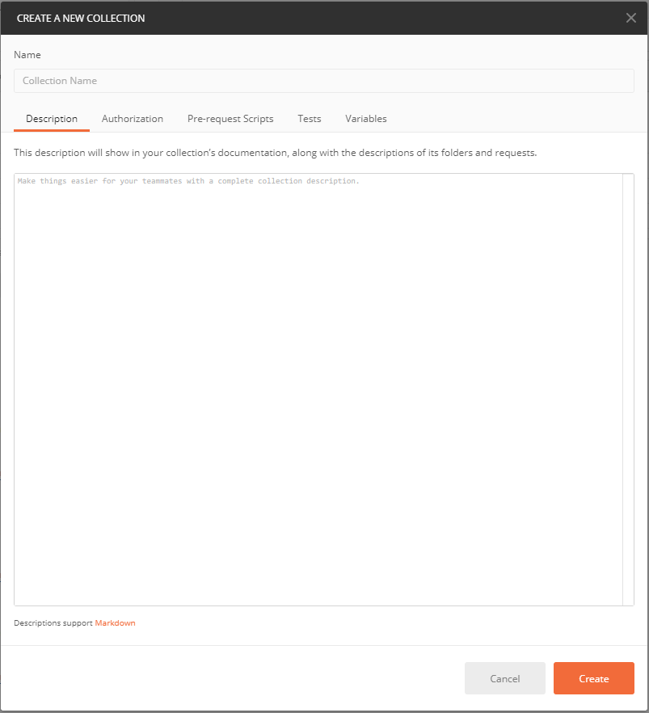

**How to run and analyze a collection:**

Go to your collection and give arrow give on right side of collection tab and choose  from it. A dialogue box will be open, from it, you can see many other options as well, environment, iterations, delay, long response, data and other. Click on  button to run your collection. You will have your results for collection request.

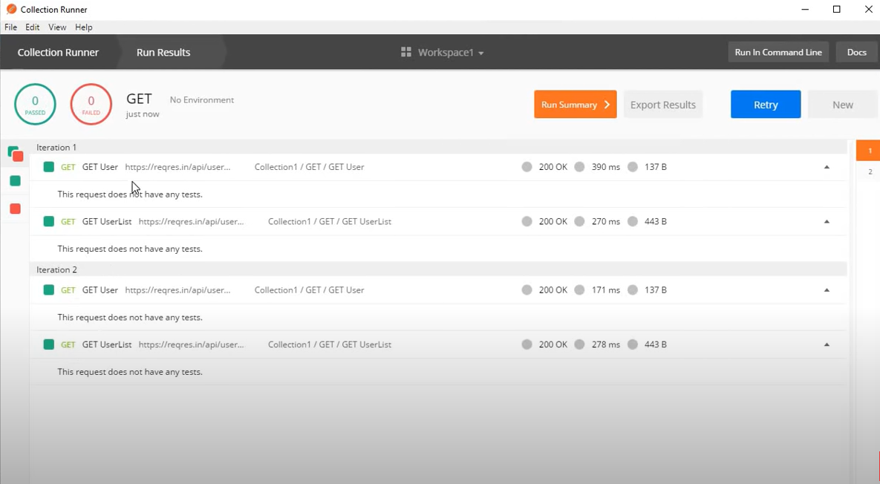

As you can see in above picture, Run Results are there with status codes, time taken to run any specific request and its size as well. Here is another option , if you click on it, you will have more high level details for pass and fail. You can also export the results in JSON file.

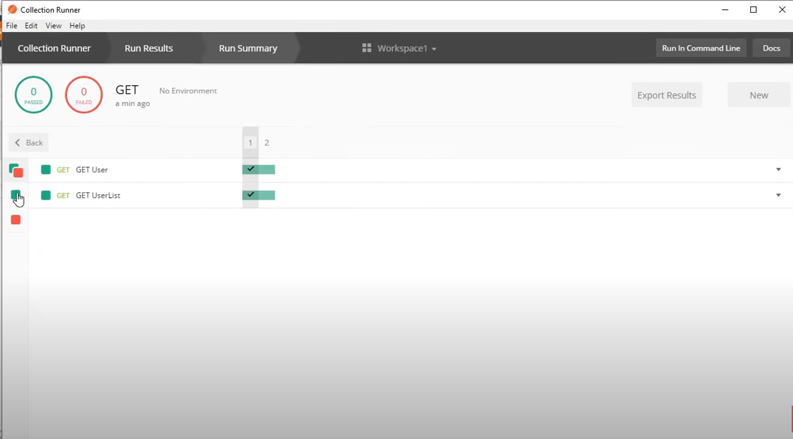

**Variables:**

Variable are any element (data store) that can take different values. We use variables because that can be reuse at multiple places, so it avoids repetition and avoid reworking when values change.

**How to create variables**

Variables can be created at multiple levels. First we are going to make it on Collection level.

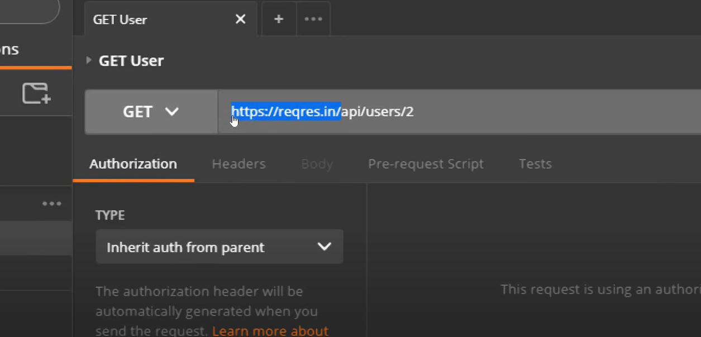

Here, we have our URL, we will make it variable, so that we DO NOT have any need to repeat it.

to create it on Collection level, go to your collection filed and click on , go to edit, a section for variables will open, you need to give key as URL and give its URL in filed.

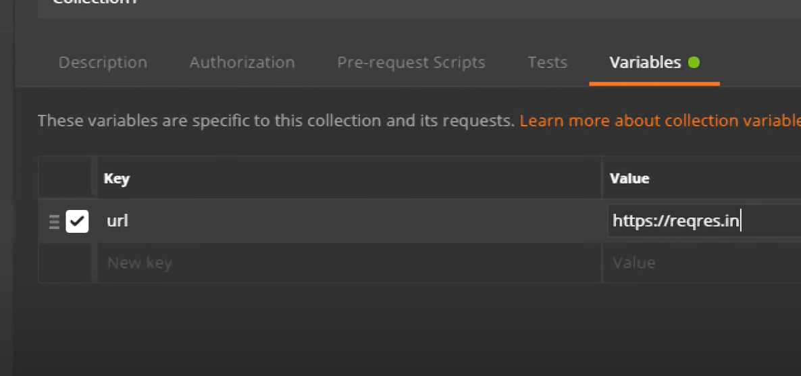

Now, to use this newly create variable, we will write name of variable, which is URL, like below screenshot.

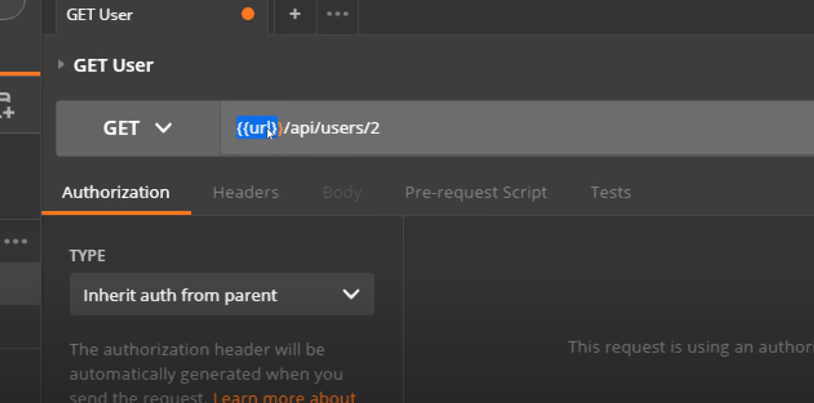

Your variable will work fine if you click send.

We can also create variables on Environment level, for that we will go to  button. This will create Environment level variable, but if you click on  button in opened dialogue box, you will be creating variable at global level. You can also check global variable by clicking on  button.

**Set and get variables through script:**

For set/get variables through scripts, click on  and start writing your script. I am writing here cosole.log(“Hello World…”);

To check response, you can click on  button and choose Show Postman Console or use short key, AlT+Ctrl+C. On send request, below is the response in console.

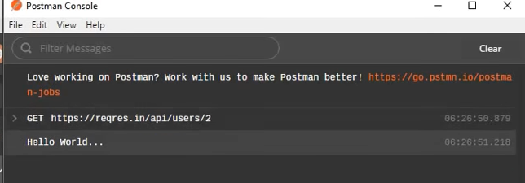

**To get variable of collection level:**

pm.variables.get(“ulr”);

Here you have another option, which is auto correction. If you are not having that go to settings and variable auto complete, turn it on.

**To get above response in any variable:**

let urlVar = pm.variables.get(“ulr”); // let is our variable to store response.

console.log(“value for url variable is: ” “urlVar ); //to print response on console.

When you click on send, you will have below response on console.

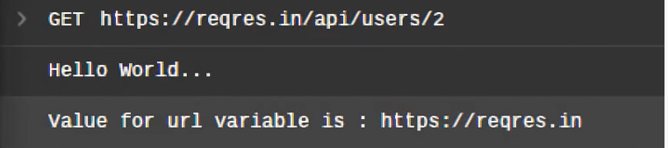

So you can see that value for url is here.

**To Set variable of collection level:**

pm.variables.set(“name”, “postman”);

console.log(pm.variables.get (“name”) ); //to print response on console.

**Global variable:**

let globalVar = pm.globals.get (“Env”);

Console.log (globalVar)

**P.S: Syntax for variables through scripts:**

pm.variables.get();

pm.variables.set();

pm.globals.get();

pm.globals.set();

pm.environment.get();

pm.environment.set();

Other than running these scripts on you Tests, you can also run in pre-req as well same as in test.

**Environment:**

It is a set of key value pairs

**How to create environment:**

Click new button and choose environment from dialogue box.

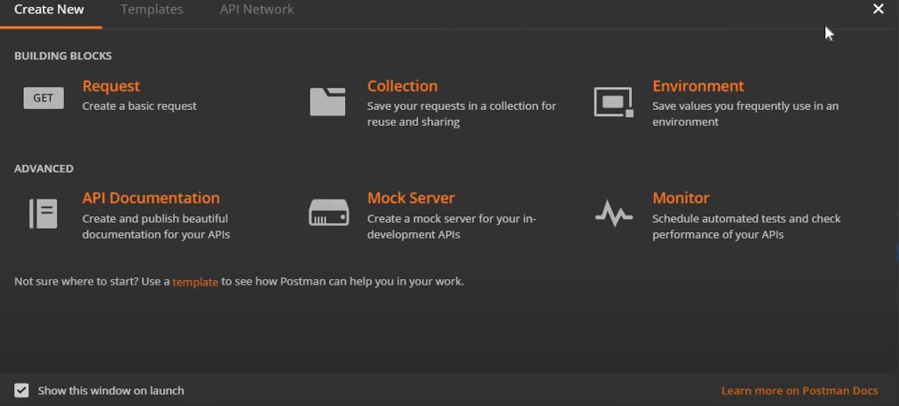

After that, have a sample API from sample site as described earlier, create a new folder inside your collection, in this folder make a new request for Post. We can name it as User Registration, and save to created folder.

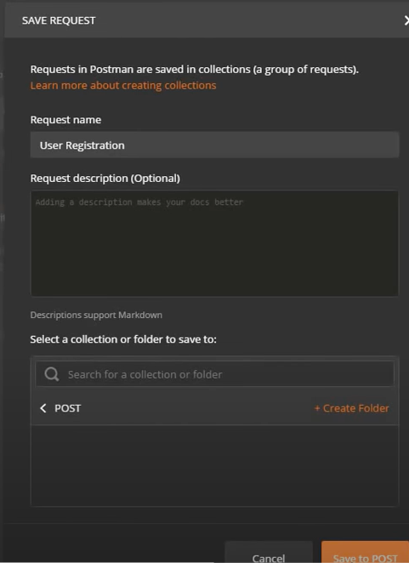

Now put URL & endpoint of request as post request in filed.

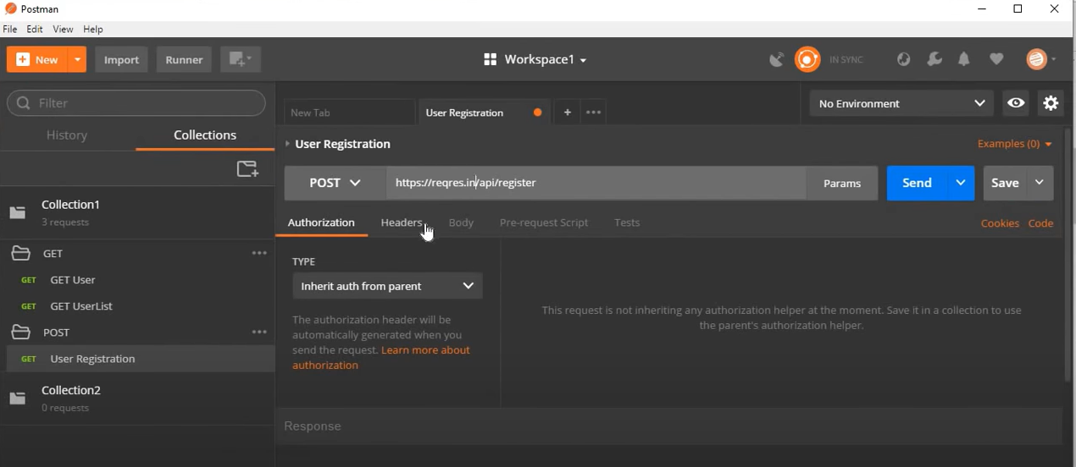

Now copy body of request and paste it in body of request and choose Raw from above options and click send.

If that gives any error, go to Header and write Content-Type in header and put its value application /json. Now run, it will work fine.

On click send, you will have response as below, you can also copy it with sample request response filed.

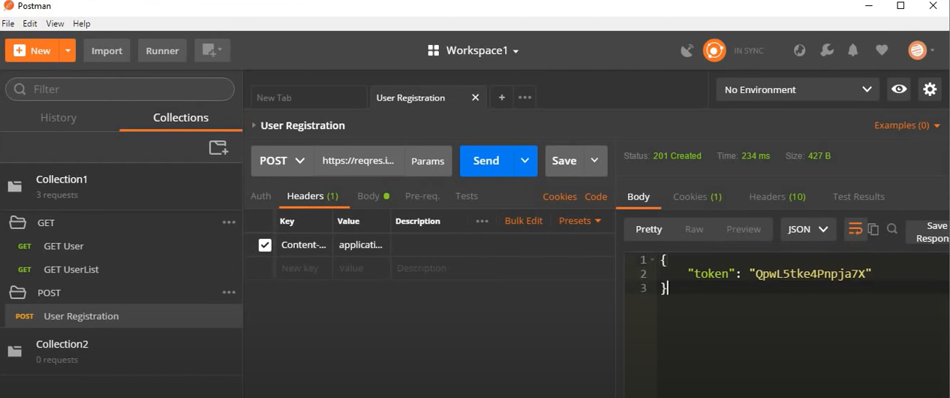

When we need to run tests, we need to run it on multiple environments and with multiple set of values and variables which may change accordingly, for that we go to manage environment icon  or go to new and choose Environment, let’s say create a QA environment and put values as given below;

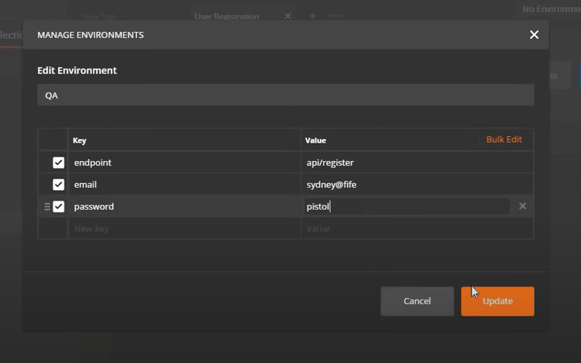

Now to use it, we will be referring it in our request body and choose new created environment QA.

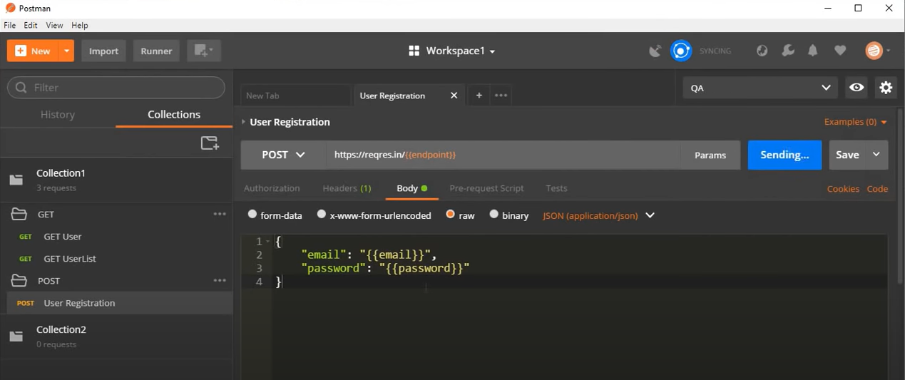

On click, I can have its results as shown in below screenshot

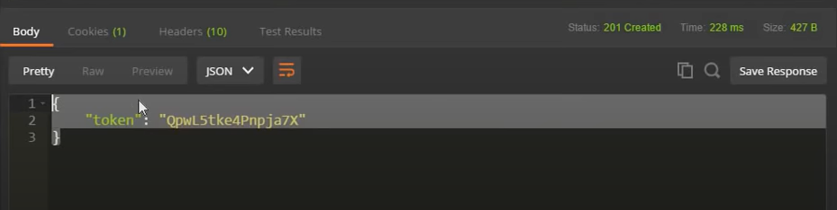

Now coming to sharing of our created environments, we can duplicate our environment into any other workspace or you may need to run multiple requests on it. Well for that, click on manage Environment button, by clicking on that, you can have duplicate option where you can duplicate environment.

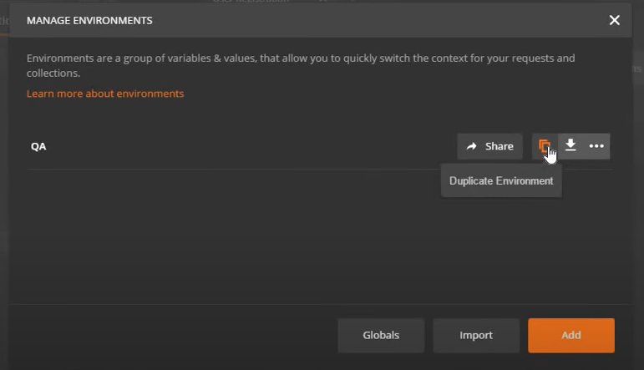

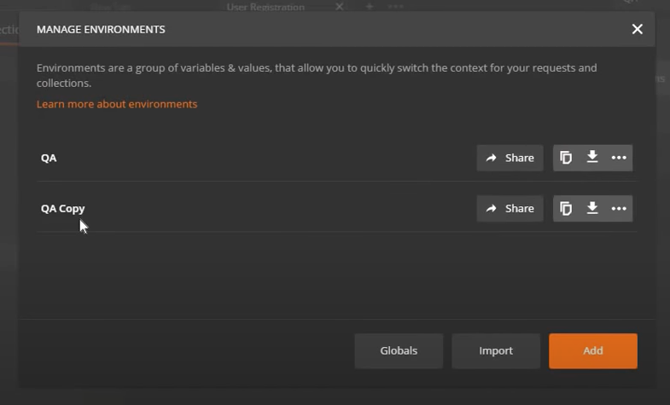

After duplicating it you can also change its name and values as well.

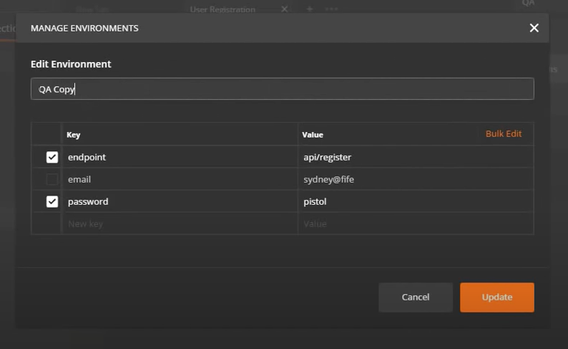

Now to use this newly created environment, just go to environment dropdown to choose it.

You can also get the same option, choose environment in collect runner as given below screenshot;

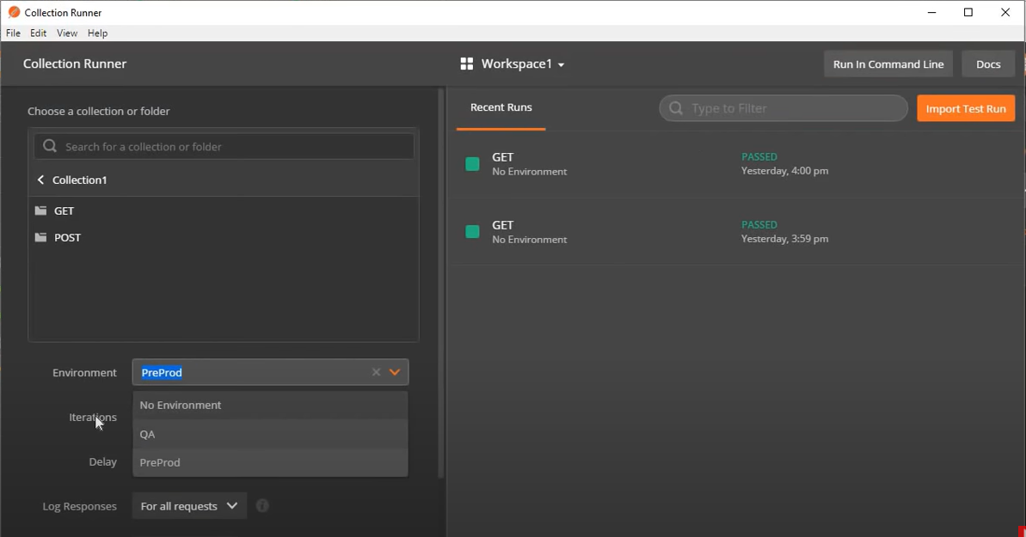

You can also delete environment, go to manage environment and choose delete.

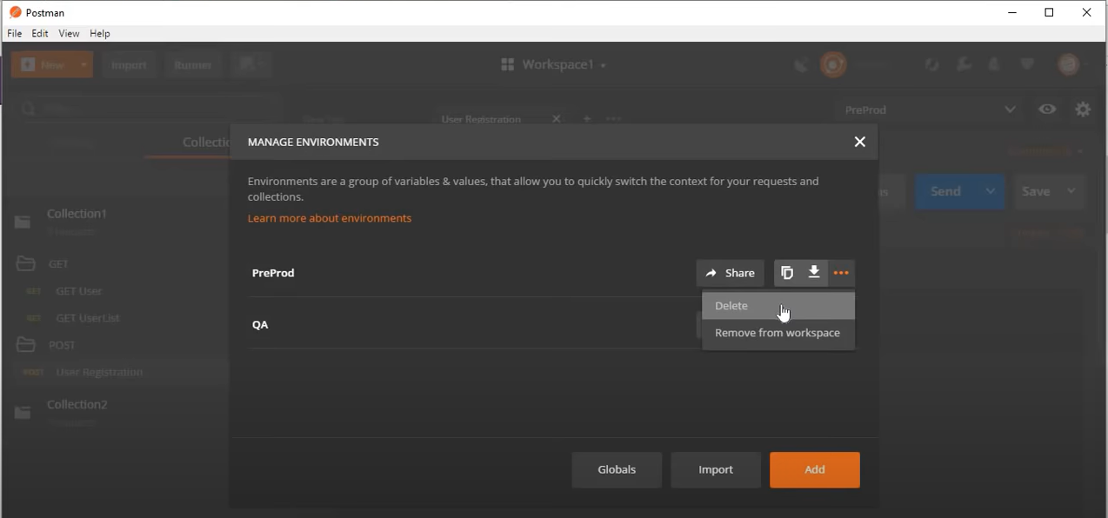

**Script:**

Scripts are templets, which helps us to create very quick scripts in postman. To create any script, go to new button, make a new request and proceed as earlier.

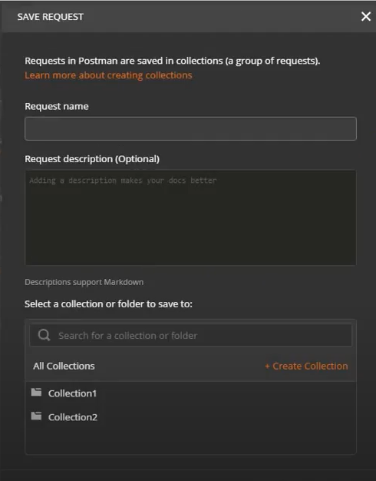

We can create scripts on multiple levels, one of those is at collection level. For that go to collection edit option. You will see “Pre-request script”, that runs before your request run and then there is another option “Test”, which will run after execution of your request.

**Script snippets:**

On “Pre-request script” screen, you will have snippets on right side, these are pre-build scripts, which can be used accordingly.

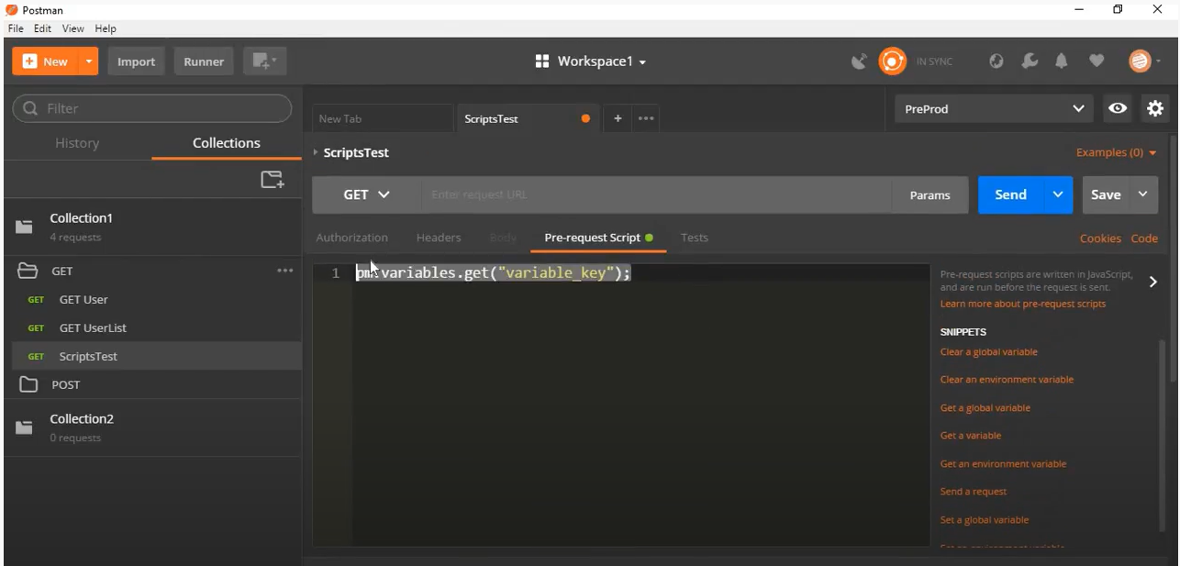

**Test in Postman:**

Postman tests are javascripts code that is executed after receiving the response to the request.

You can create test on collection level, folder level and on request level as well, to create, go to edit in collection/request, there is test option in opened dialogue box. Click on the test and you will have test builder section, on right, there is snippet section, you can choose any test from it.

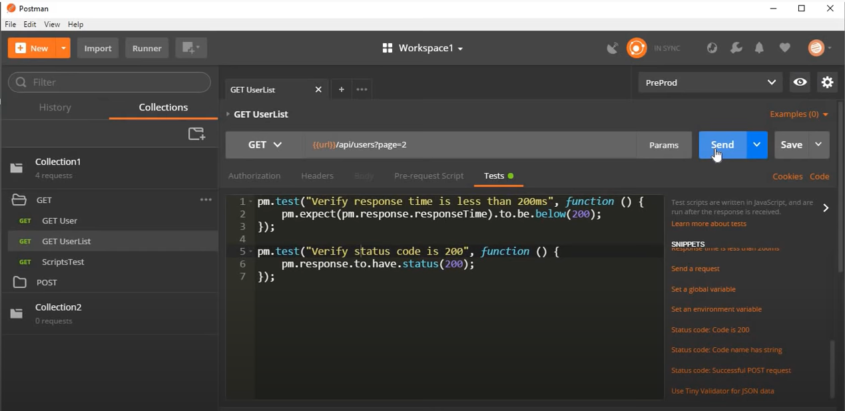

On click send button;

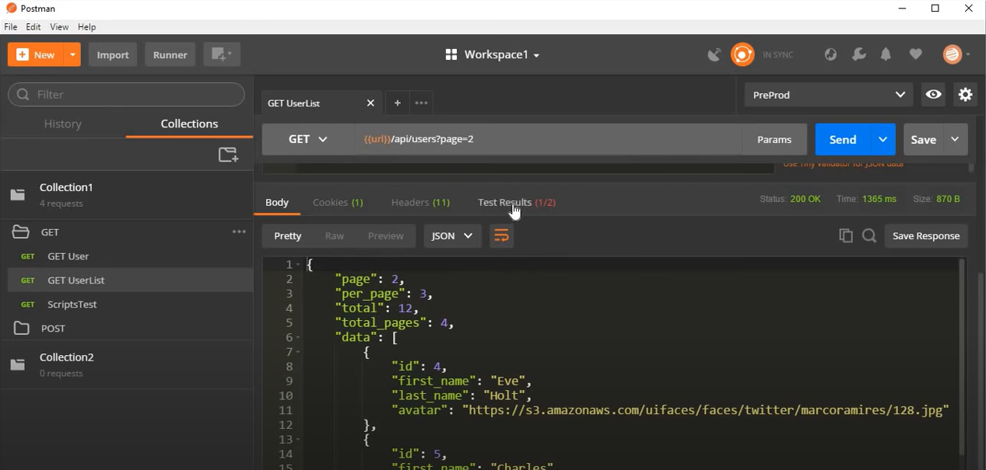

You can see results option as well, in it, it is ½, means 2 out of 1 is fail, let’s see it in details now;

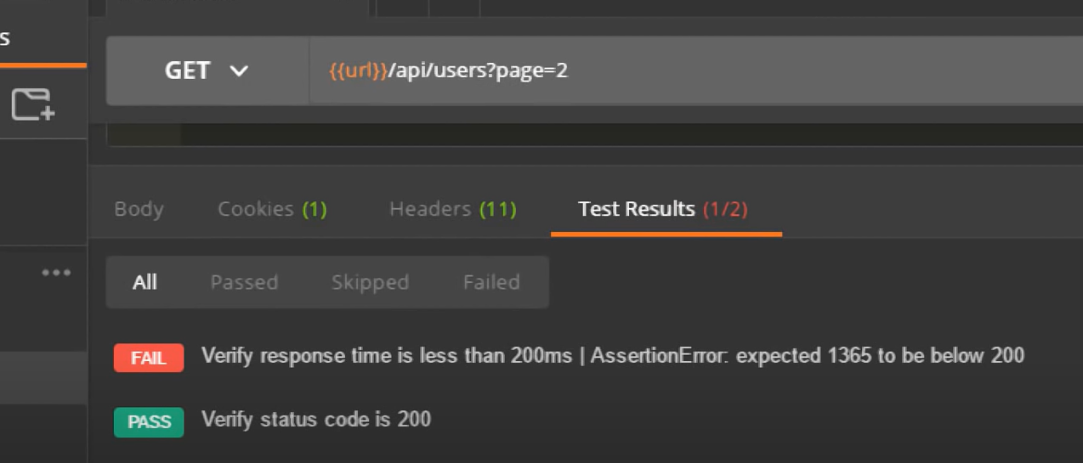

You can see that first test is fail as we were verifying is response time less than 200ms and time was 1365ms, so that’s why it has failed.

You can also run your test from command line, go to your collection, click on arrow button and choose run, you can choose environment from opened dialogue box and run your collection, now along with the results of our requests, we are also having the results of our tests. You can also check Run Summary.

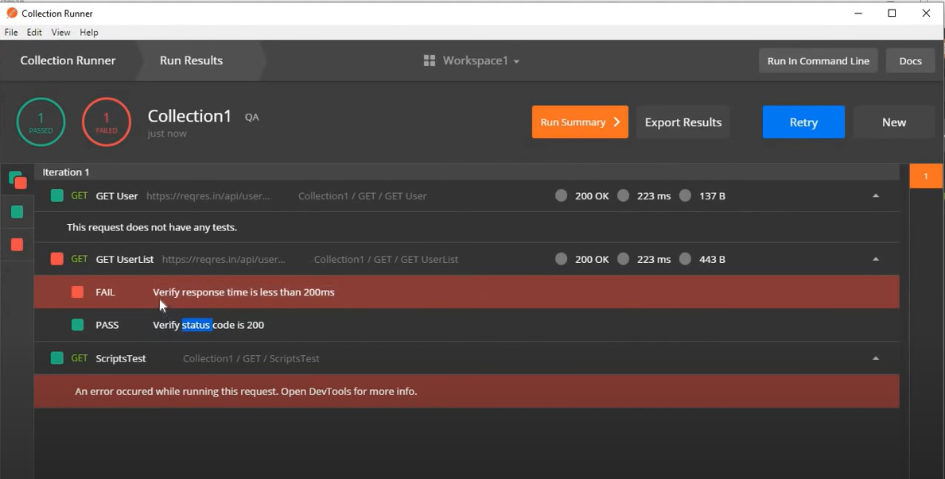

**Run Summary:**

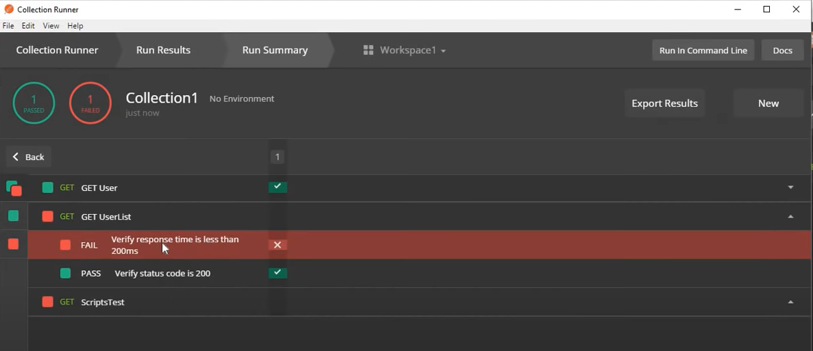

**Debug with postman console:**

Postman console is the best tool to debug, click view option and go to “Show Postman Console”, to open Postman console. Now go to get user request and click send button to check the response.

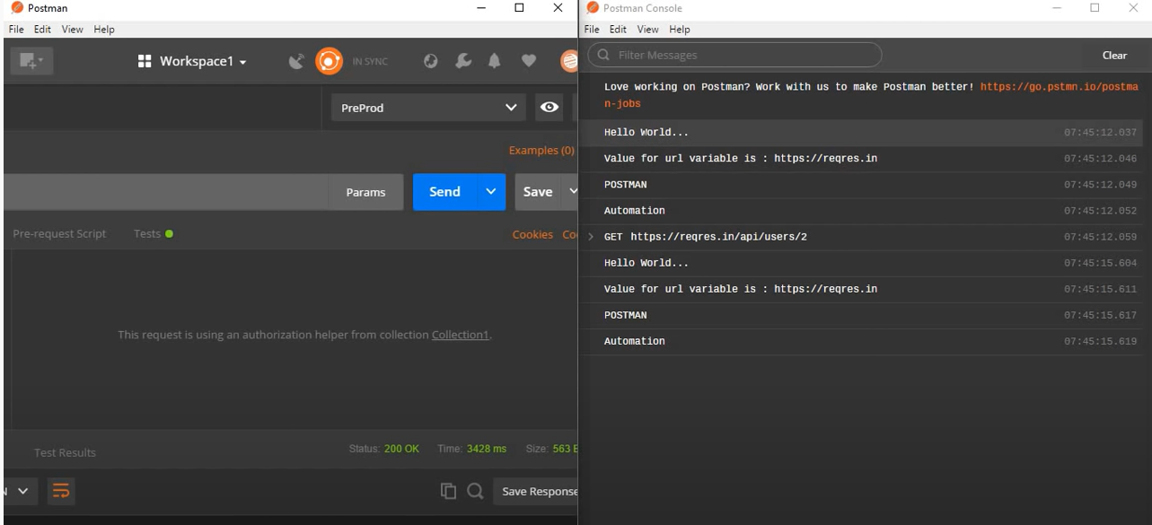

Let’s say you have some script or test case and you also want to log it for different sections or levels, you can use below commands and you can use these where you want to do. There are two places to use it, one is pre-request script and other is tests section and these are available at collection, folder and request level.

Similarly, if you write script in pre- request, it will be run before running request. So that you can log different information, error or warnings at different locations to debug or etc.

Clear logs

Console.log()

Console.info()

Console.warn()

Console.error()

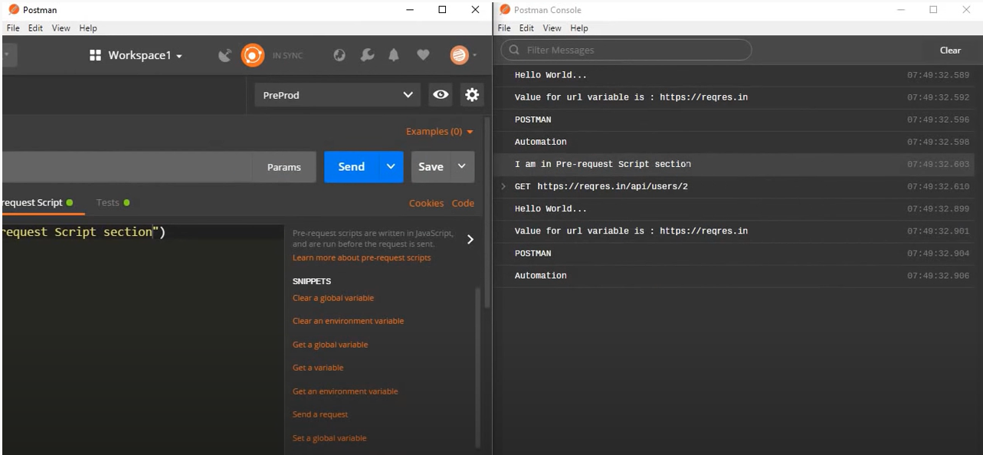

Another good practice to debug or troubleshooting, you can check App debug log, for that you will go to view > developer and choose Show dev tools (Control + Shift + I). ON click you will see all the elements, console, sources, network and many more. These are very useful information for deep drilling into sources and logs.

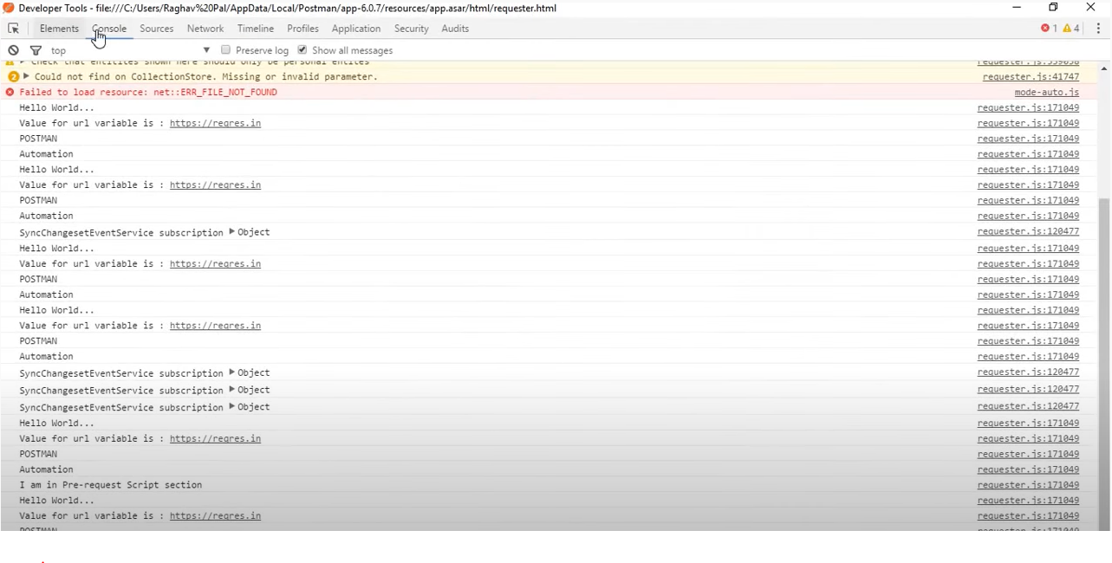

**Running Postman from command line (Newman):**

Newman is a command line collection runner for postman. For command line postman we need to have Newman installed into system, below are the steps for that.

* Check is node.js already installed in system, to check, go to command line and write “node -v” and hit enter. In case you have version of node, that means you have that, otherwise you will have below message screen.



* You can also try with npm (Node Pack Manager) which use to install command line packages on node, for that write “npm -v” in your command line and enter, if you have below message that means you don’t have that and you need to install that.



* Now you need to installed node.js and the reason we are installing node.js is that newman is a node.js program and for installing newman, we need to install node.js. So for that, go to browser write install node.js

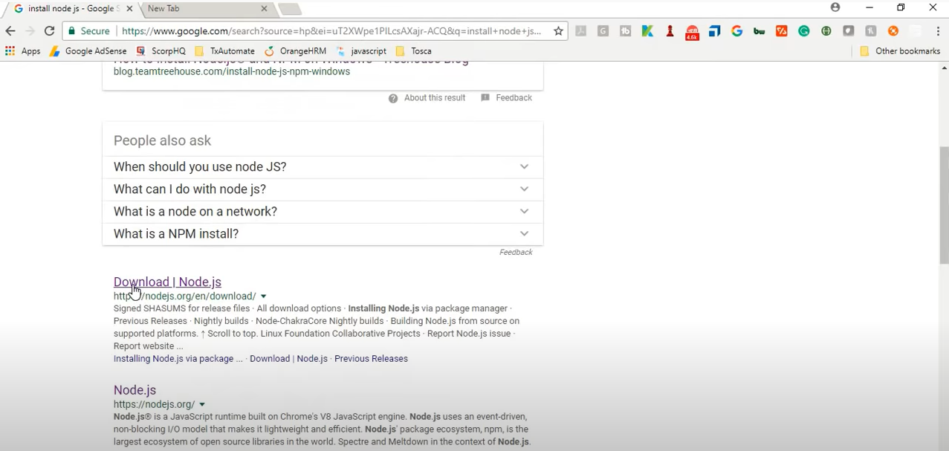

Go to <https://nodejs.org/en/download/> for downloading of node.js. There will be 2 option, LTS (Long Term Stable Release) and Current, we will go for LTS. Click LTS and go for ‘Windows installer’ and run it once it downloads.

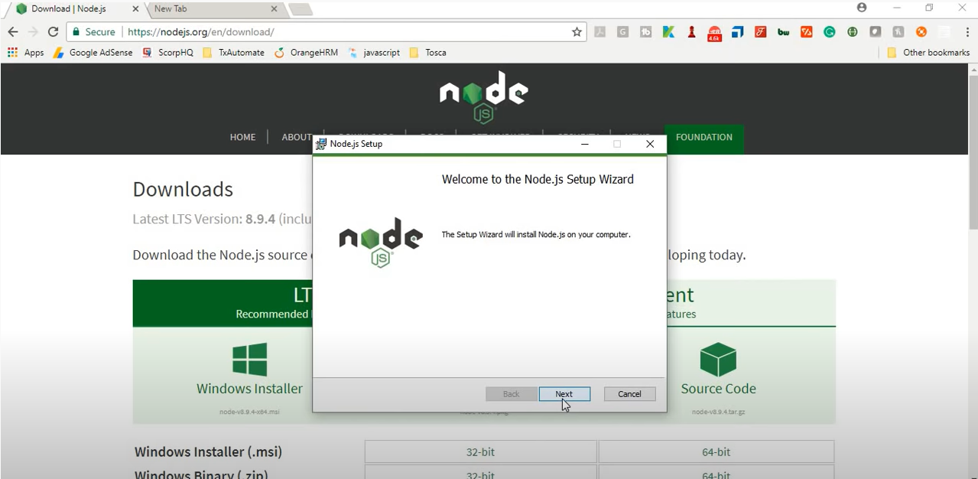

By default, it will be installed in C drive, you can also choose if you want to.

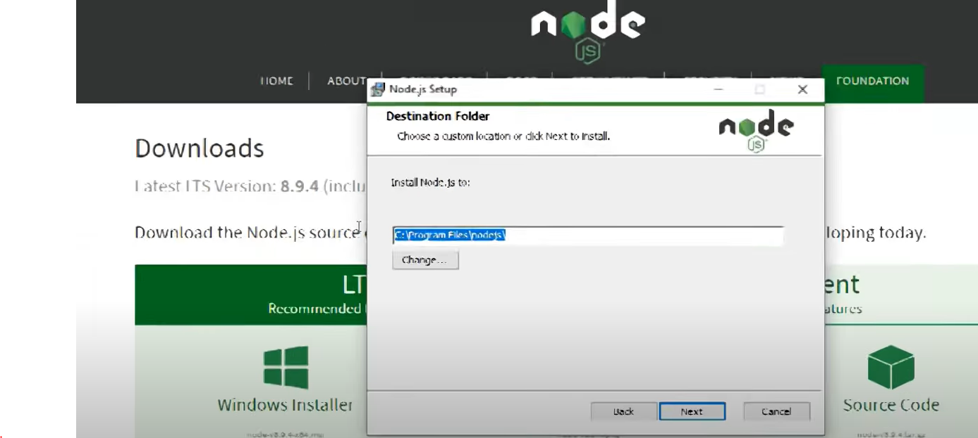

In next step you can also see npm package manger getting installed.

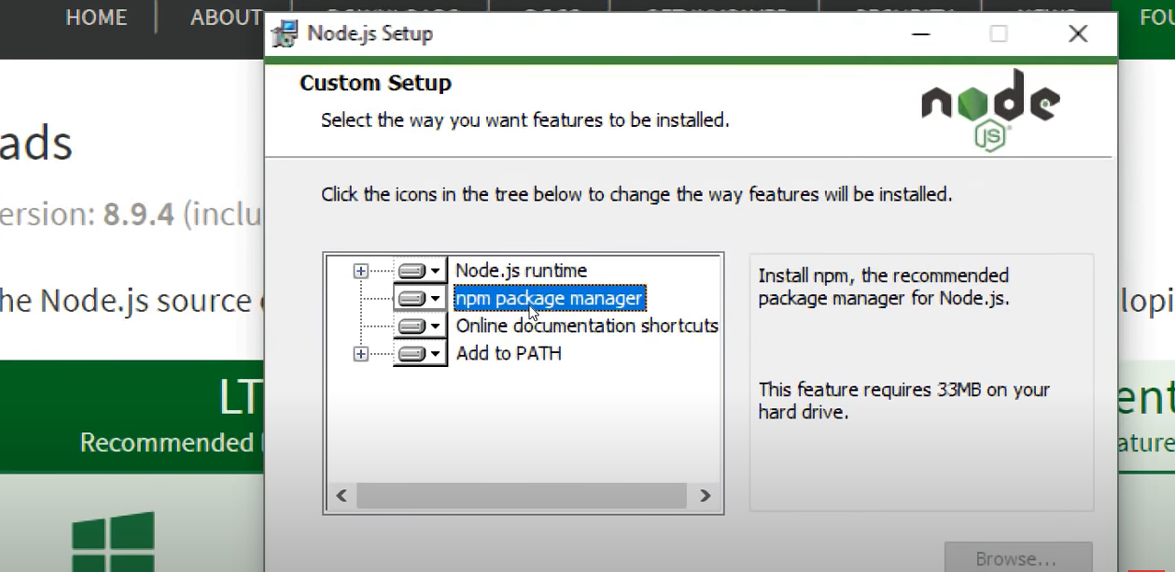

Now after this procedure of installation, if you go command line again and write “node -v”, it will return you its version. Secondly, enter “npm –v”, you will also get its version. Which means noth node & npm are up running on your machine now.

* After node & npm, you will install Newman. Write “npm install –g newman” in your command line and hit enter.

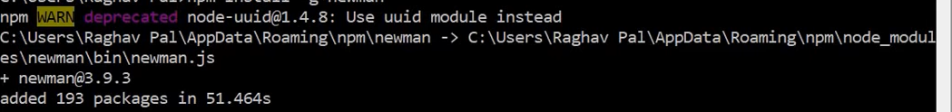

* Step 3: Export collection as json file. Go to postman and whatever collection you want to run just export it as json file.

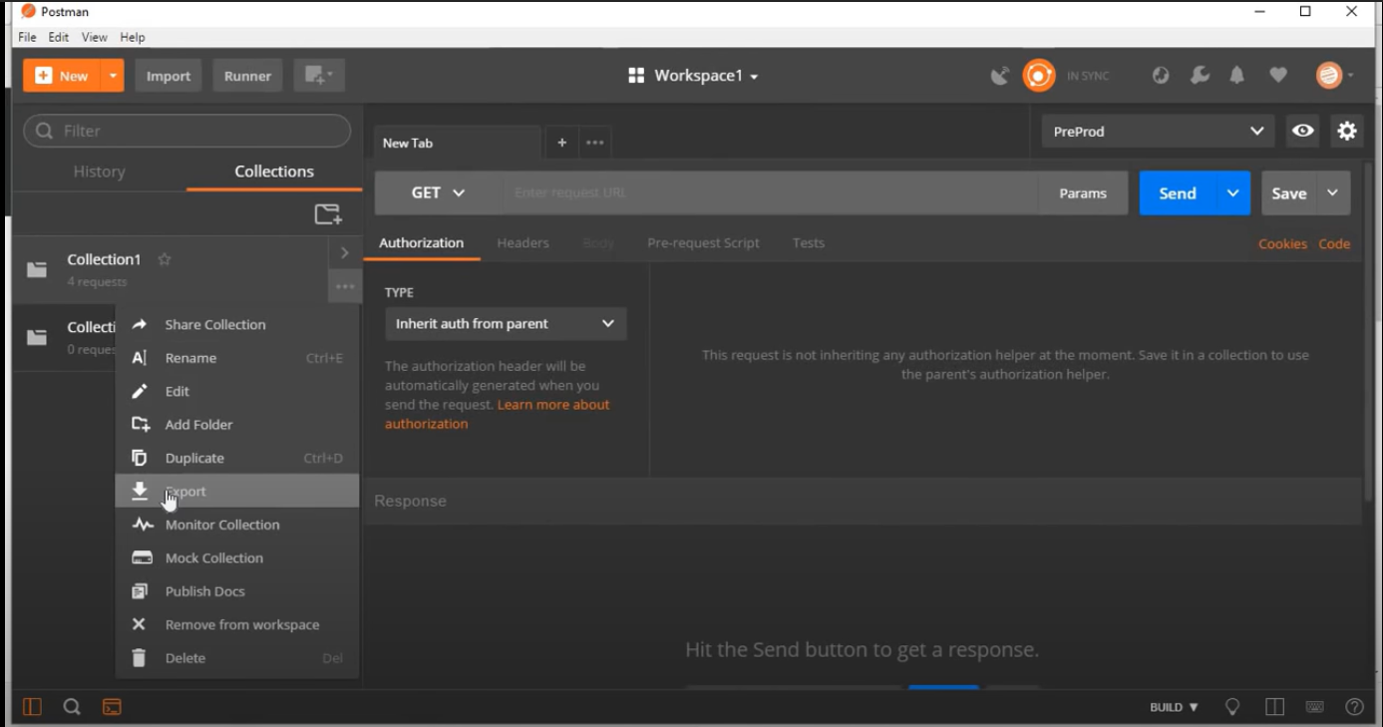

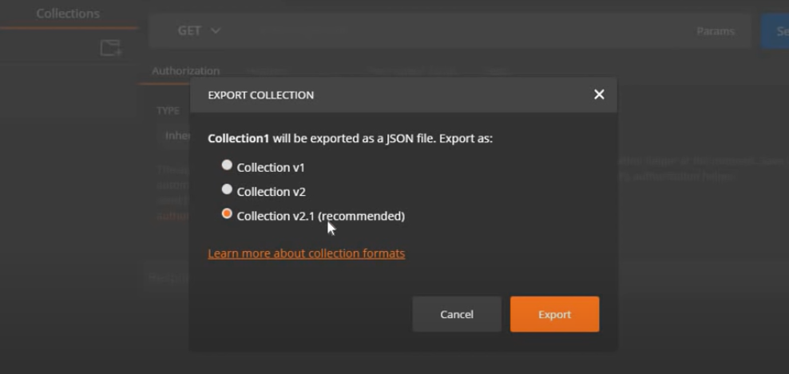

* Step 5: You will open command line and go to location of collection you just exported in step 4. You can copy the location, write ‘cd’ and then paste path. You are inside the folder.
* Step 6: Run command, as **newman run collection_file_name.json** and hit enter.



You will have the response ad all the requests inside the collection will run;

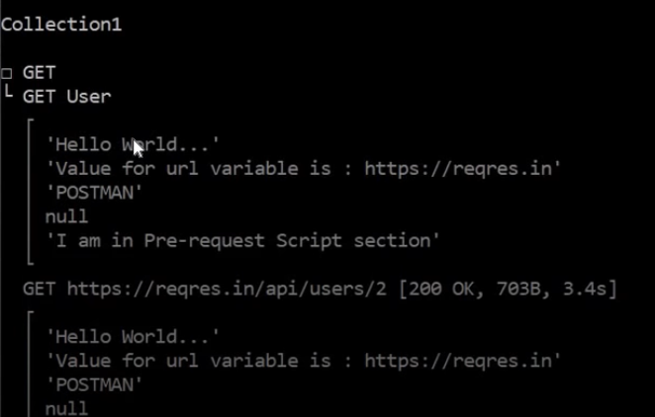

You will also have the summary of requests run.

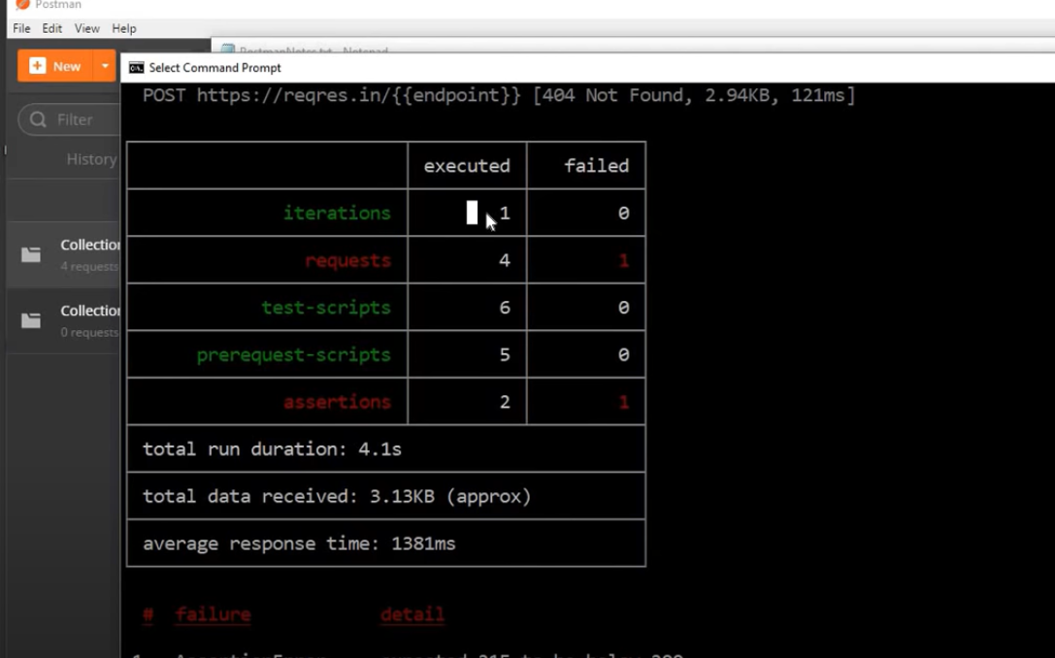

You will also have average response time and in case of any failure, you will have its type and details as well;

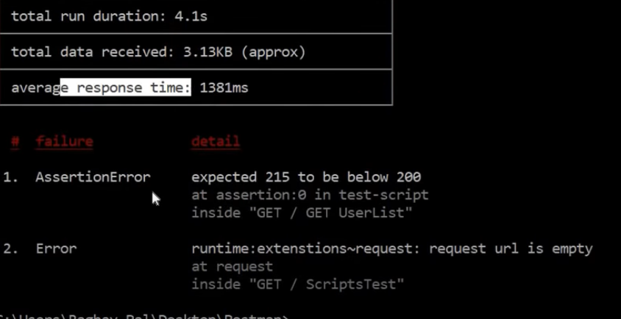

Tip: Go to command line, write “newman -h” and hit enter, you will get all the options you can work with in newman.

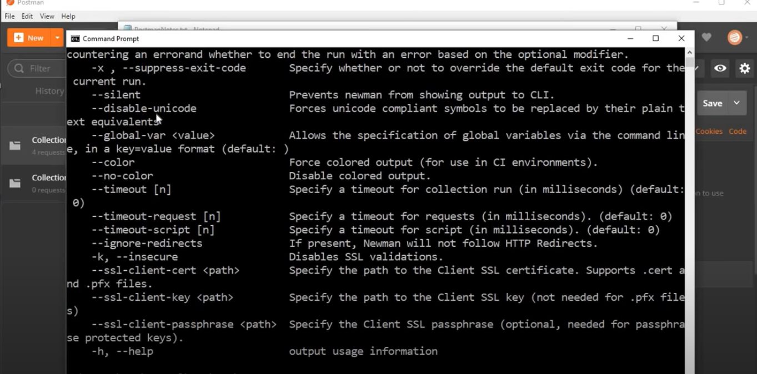

How do we setup postman job in Jenkins:

You have your Jenkins local server up and running and go to ‘New item’ and create a new job. Choose ‘free style’ and hit enter.

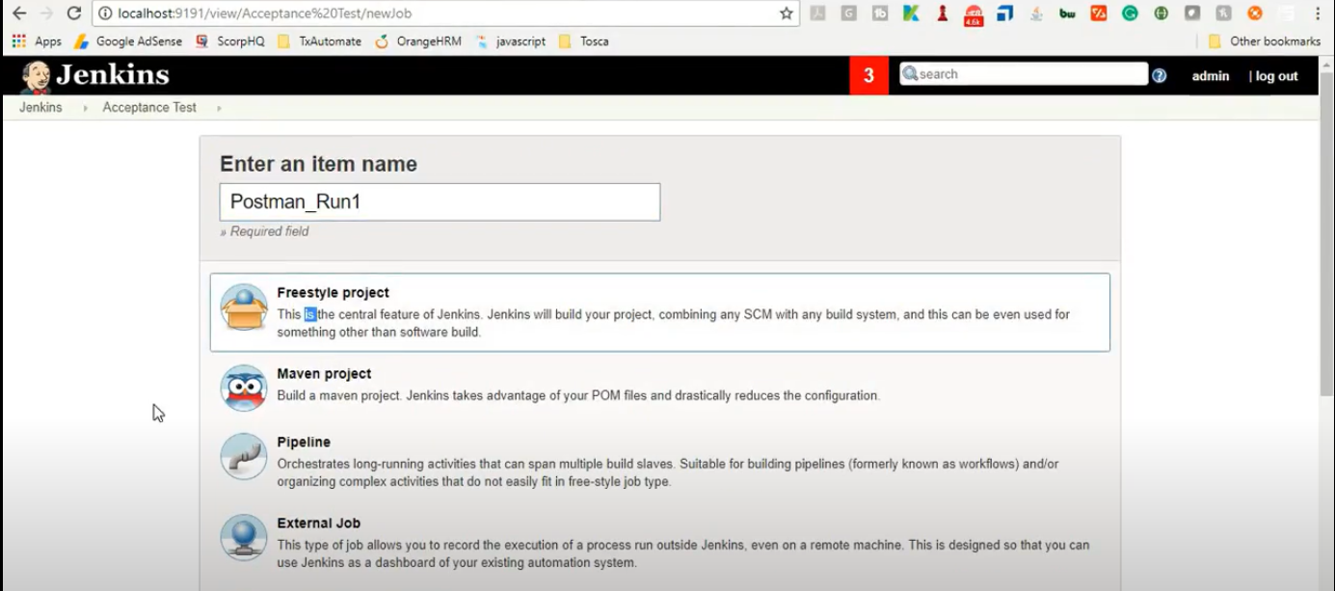

Now you will configure it, go to ‘build’ section and select ‘Execute Windows batch command’ for windows. In next step, you will enter command to execute your collection, it will be the same command which we have learnt previously. So go to location of your collection first and then write command **newman run collection_file_name.json** and hit save the job.

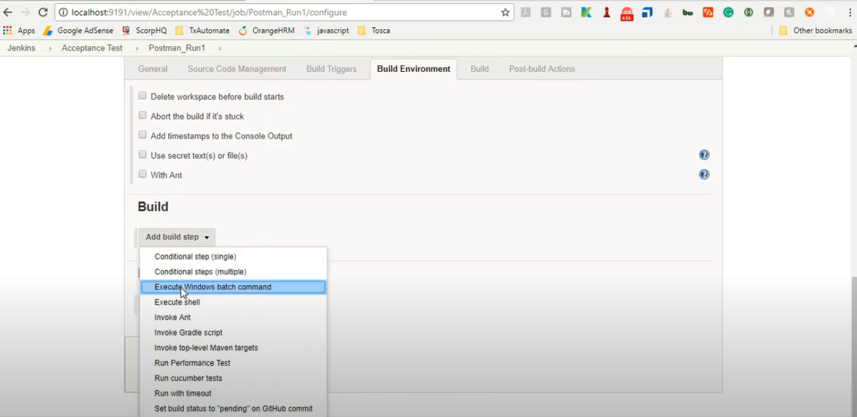

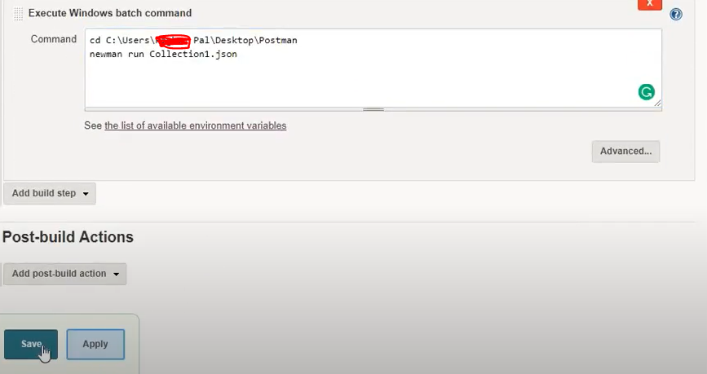

Next step is just to go “Build now” so that you can run your job.

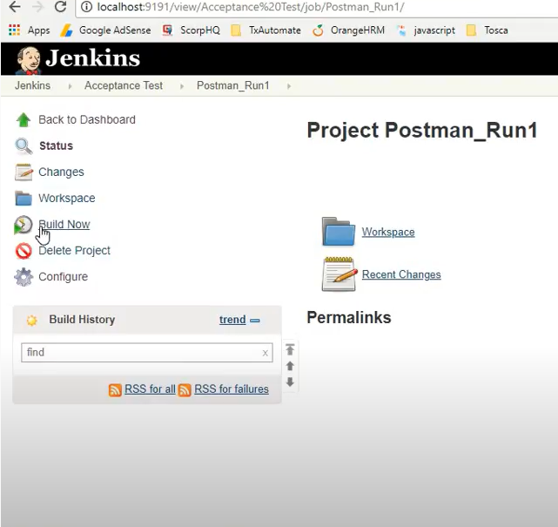

After build created, go to “Console output”, click on “plain text” and now you can see your collections running on jenkins.

Tip: You can also get your project in Jenkins via Githib repository, you can also build triggers and etc.

**Workspace:**

Workspace in postman is an area where you can group, organize and manage your collections and it is available on postman versions higher then 6.0.

Creating, managing & sharing the workspace:

Whenever you start postman, you will see ‘My Workspace’ by default, here is create option you can create your new workspace form here. We have two types of workspaces in post, one is personal and other is Team, which is shared workspace within team and available with Postman Pro only.

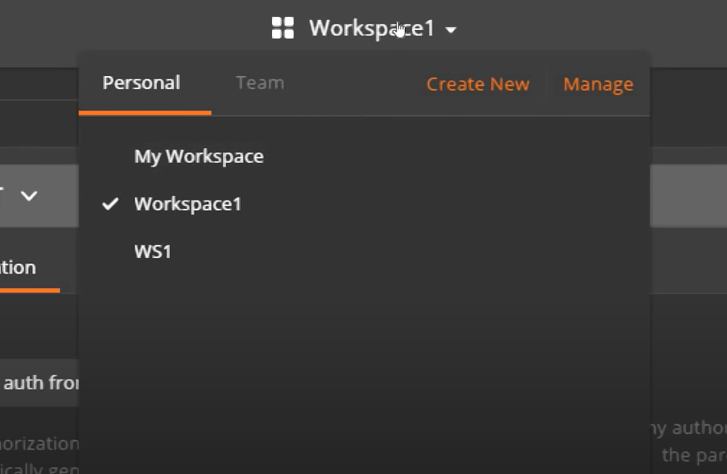

Go to ‘Create New’, give its type, name, description and hit create workspace button. You will have the newly created workspace in your workspace list now.

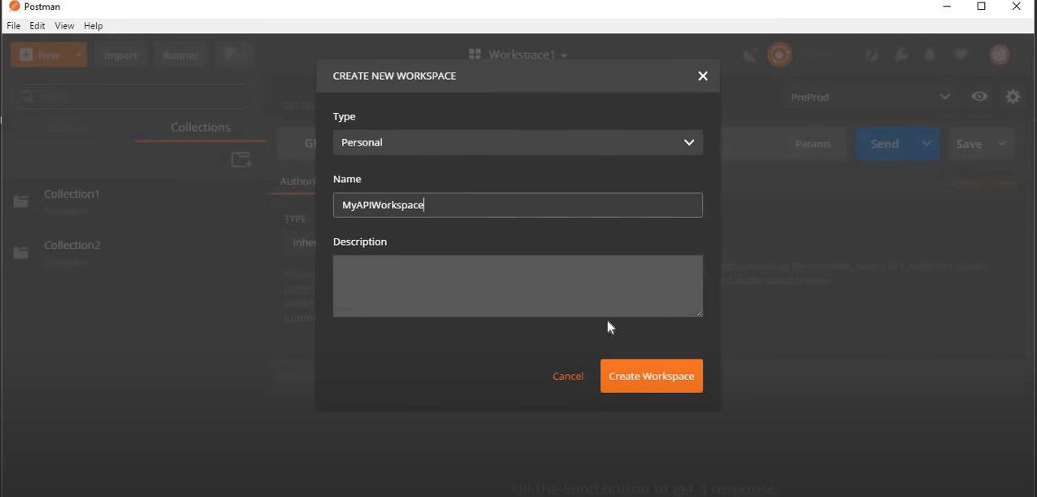

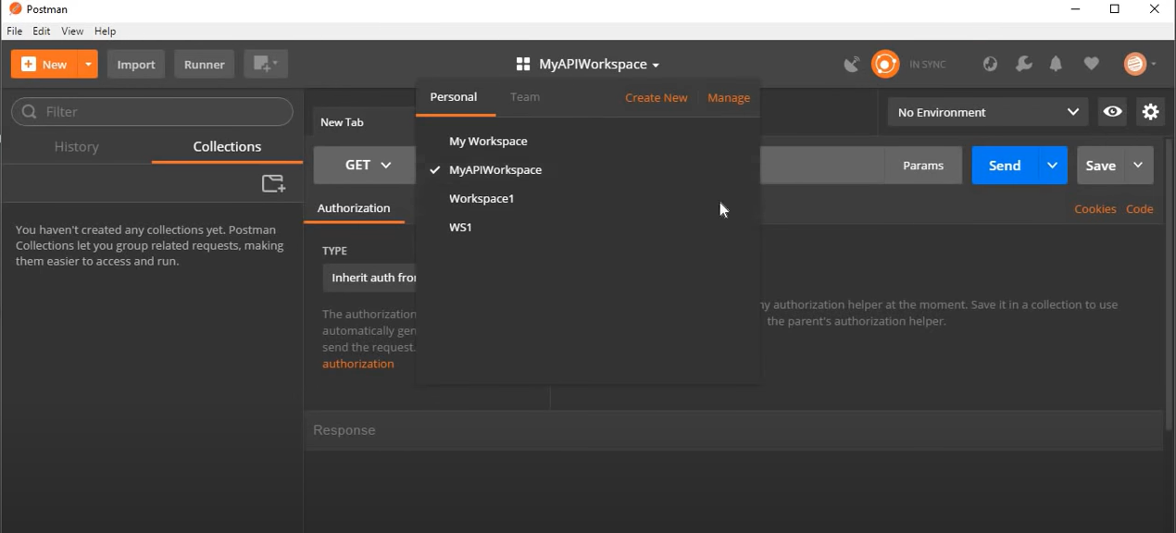

If you look at right bottom corner, you will find a button  if you click and there will be another hidden option called ‘Browse’, click it, you will have all the details of your all the stuff you have in workspace.

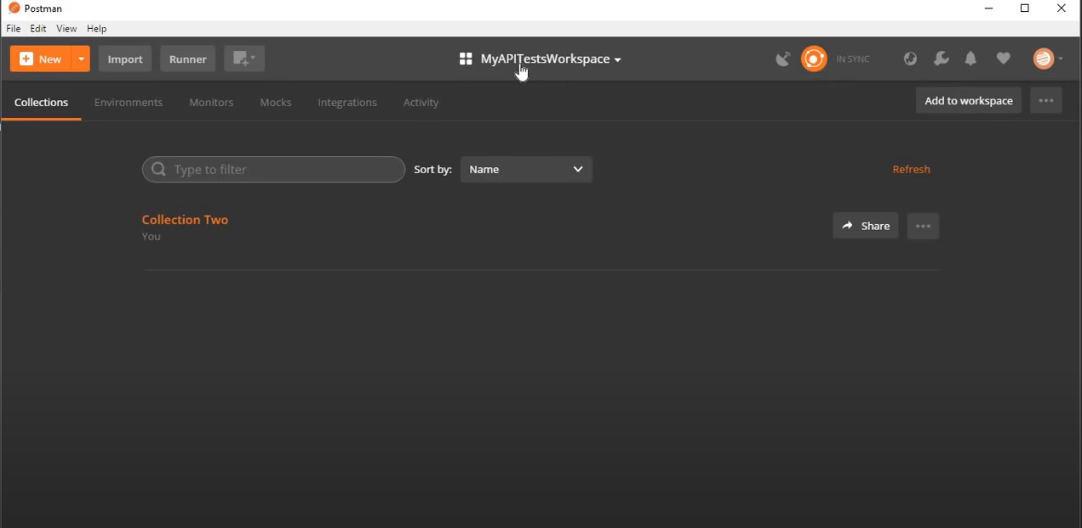

You will also find an option at right top corner, “Add to workspace”, from here you can add any of your workspace’s collections or environments to opened workspace by choosing source workspace and other.

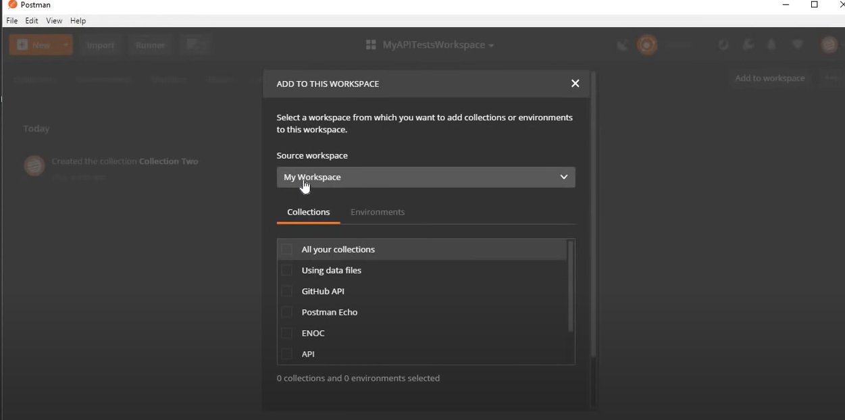

After adding, you can also check, go to ‘build’ option, select build from arrow, you can see newly imported collection/environment in your current Workspace. You can check the same in browse option as well. You can also rename, delete it from collection options as well as from build.

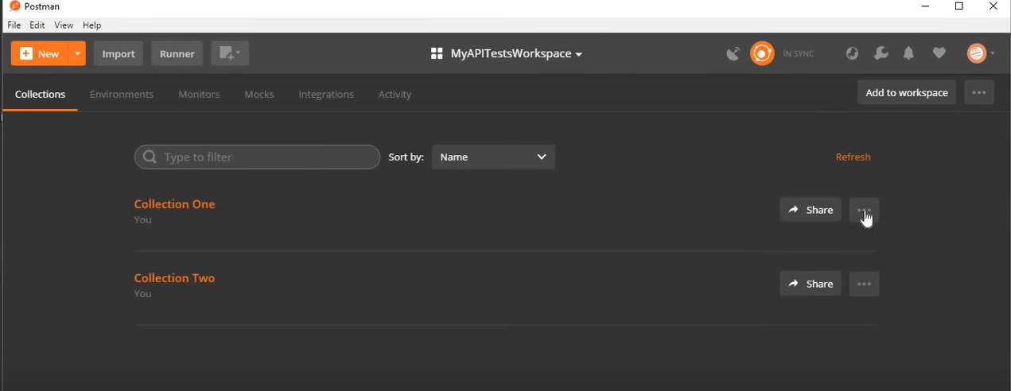

**Postman – Data Driving Testing using JSON CSV data file:**

Create a sample API from reqres.in, copy the URL, endpoints and body as well. Put URL and endpoints to get filed after creating new request. Paste body in body section of request and choose ‘Raw’, now click on send, you will have your results. You can also compare it with sample results.

Other than that, if you append something into endpoints after ‘/’, you will see that in results there is all the info which you gave in body as well as its ID and created date. Which is good for insertion and deletion.

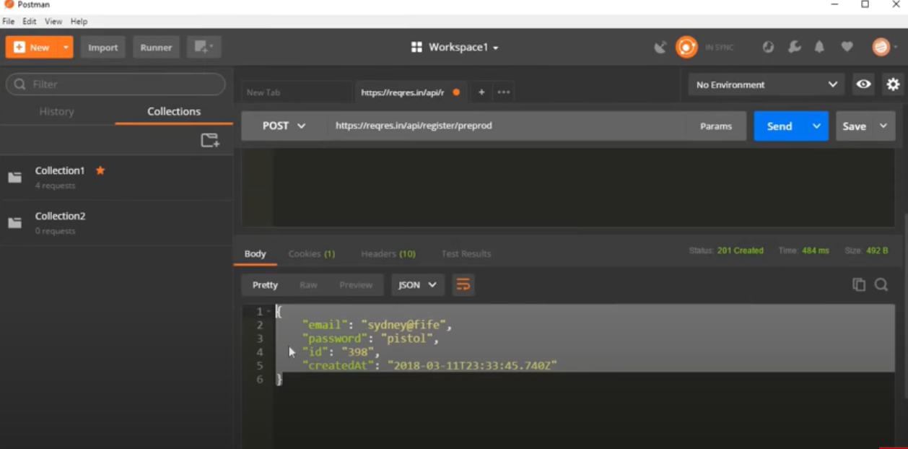

Now our request is ready, now we have to refer variables into request, I can refer some of my value with variables.

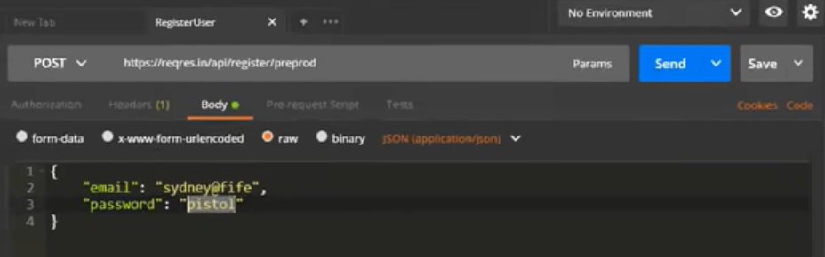

So I have picked few of these values which I am referring via variables;

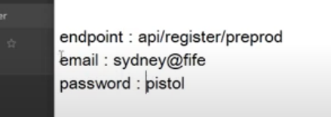

For creating variables, as we have learnt previously, I am making it on collection level, go to option of collection and choose ‘Edit’, here you will find a variable section, I am putting above values here;

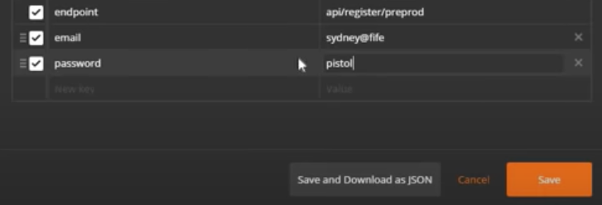

Now replacing all the values with variables like {{variable_name}} and check by clicking send that your request is working or not.

You can also go to collection runner from collection and run it from collection runner as well. Here if you see, by opening collection runner dialogue box, you will see ‘Data’, from here you can choose both CSV and JSON file. This is the option use to give variables from CSV & JSON file, instead to give it within collection, request, environment or globally.

For that, I am creating a CSV file in my machine. Here I am entering the same variables;

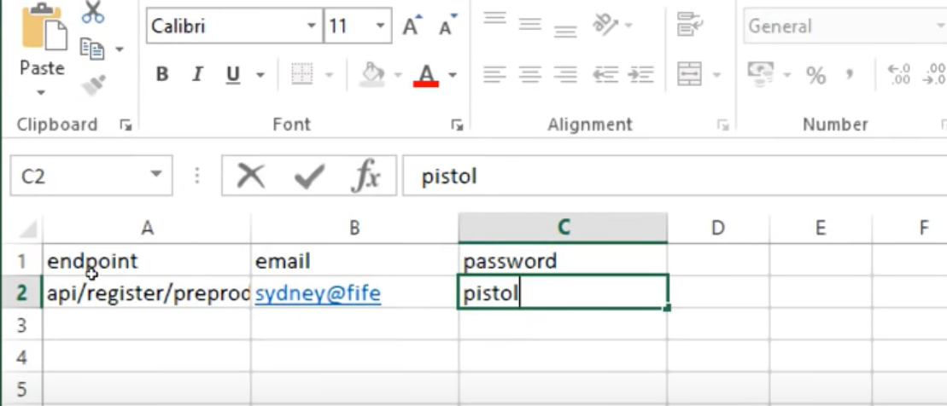

I will save and close it, go to collection runner and choose the file from Data option, we discussed it earlier;

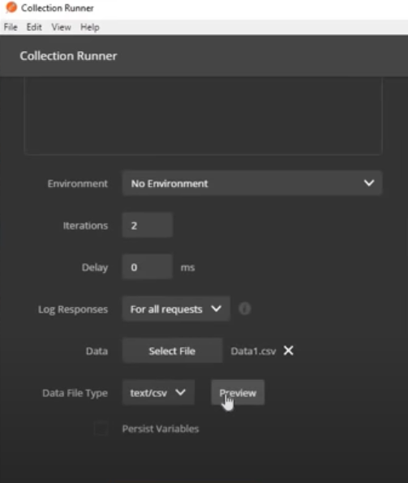

Here you can see, there is already text/csv option in it as well as preview option, it is very useful option. When you click on preview, its format will be just like a text file, means the formatting is not proper. Here is an issue. You need to go to your CSV file and open it with text file, here you see there is no comas. CSV needs comma separated values.

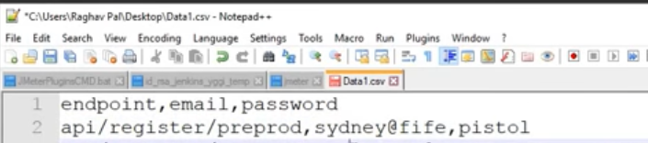

Now choose the file via the same procedure and preview, it is perfectly fine now to work on.

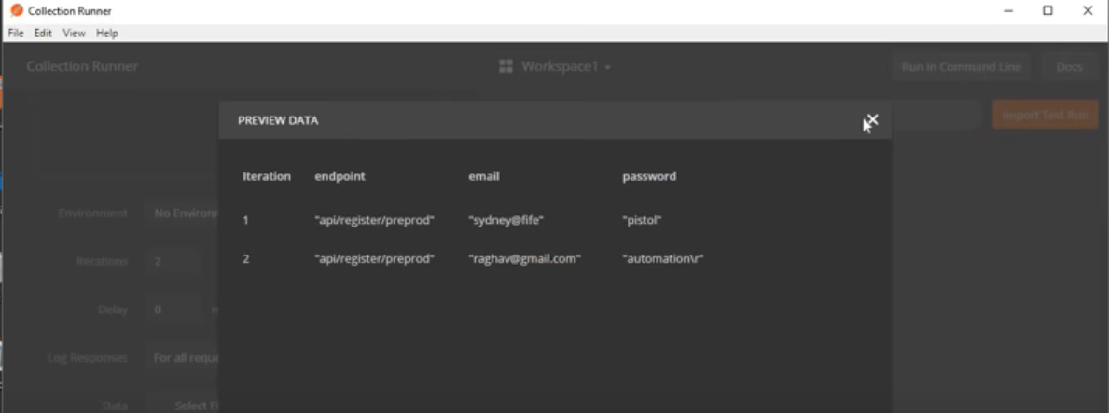

Now you can run it and check details as well in body request.

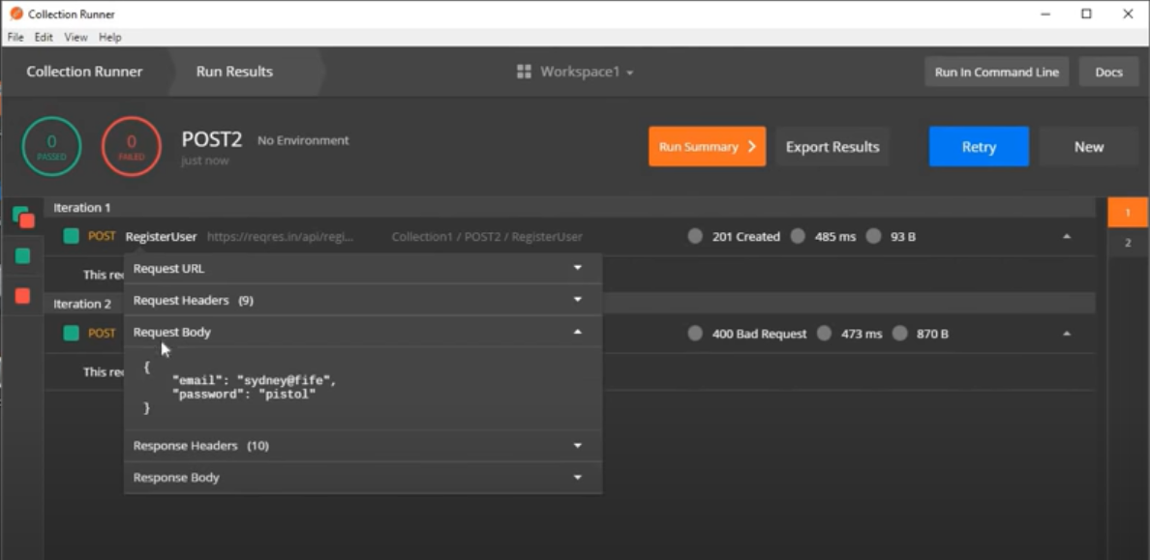

You can create a json file with json format to refer variables via json as well.

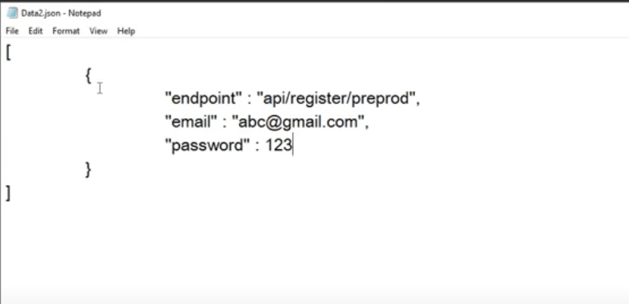

Now go and choose newly created json file and here sometime postman do not have data file type by default, so click on dropdown and choose ‘application/json’ and see preview to check and run now, Yes, it is working fine and taking values from your file.

P.S: This is all fine to run Data Driven API requests, but for runningdata driven tests process will not be the same.

**Data Driven Tests:**

If we need to have variables for test from external file, we need to be writing few line in ‘test’ section.

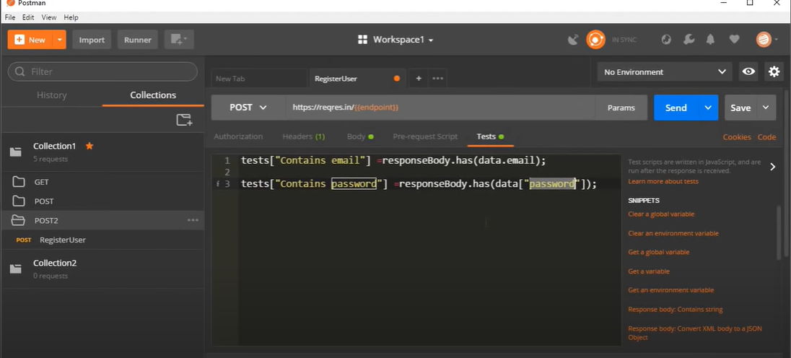

Now just save it, go back to collection runner, choose the requested collection, environment from dialogue box as well as file and preview it as well to verify it. Now run post and you will a run result screen like below, which contains password and email.

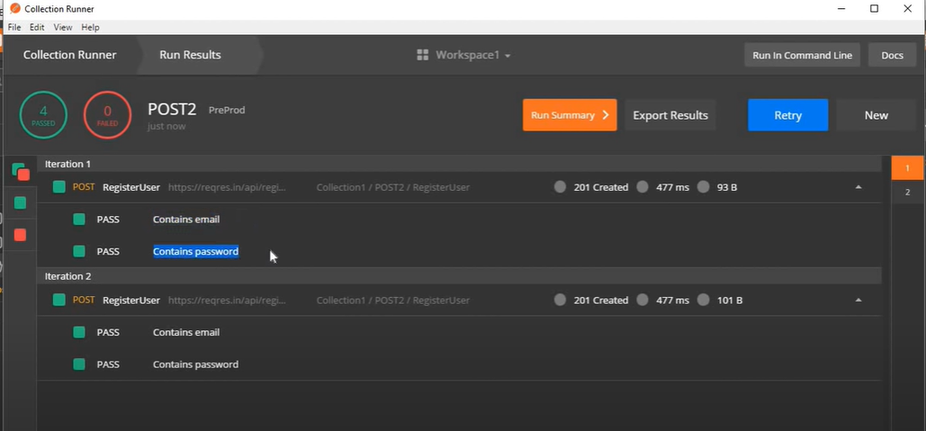

You can also check your request data & response body in this screen, for that, go to ‘Registration Body’, there you will see all request body, which have email and password both.

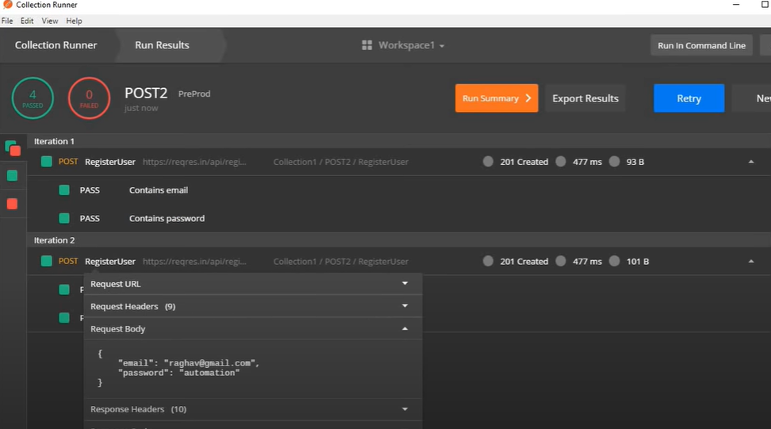

**Tip:**

Data variables can be used where environment variables can be used except in pre-request and test scripts.

**Run collections remotely:**

Step 1: Go to your collection and click on  button and choose share collection option or you can go to  button and click on share option. After that, there will be a dialogue box, from that choose ‘Get Link’ tab and click on , in result you will get link for collection.

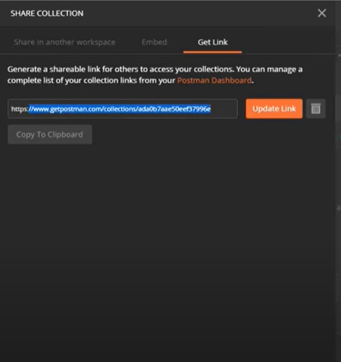

Now copy the link and goto command link, here we can run our collection using Newman tool. Now give command, ‘newman run’ and followed by link you copied. Hit enter and you will see it starting giving results as normal collections give.

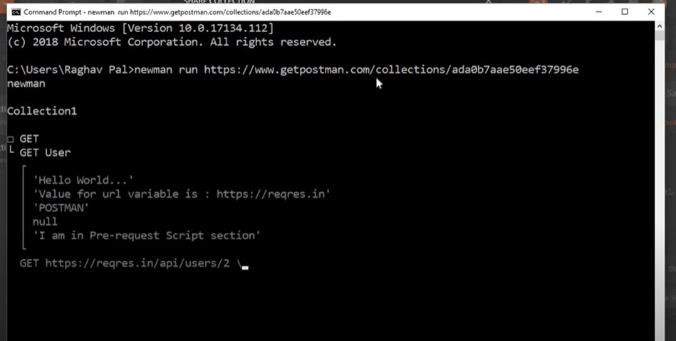

**Running Collection from Remote machine/sever:**

For doing it, you must have newman in it, if not, please install it first, as we have done earlier.

Newman –v to check is it installed.

After checking, write ‘newman run’ and followed by link of collection we copied and hit enter. It will run the same collection. You just need newman and URL, you don’t need to have postman on remote server/machine.

**Adding SOAP request in Postman sample:**

For that go to your browser and search for sample SOAP request, for that, we can use (WSDL) Web Services Description Language, which is used in SOAP or any other SOAP request. Below are the steps to add SOAP request in postman;

Step 1: Get SOAP request URL or WSDL URL and paste into request field in postman.

Step 2: Set the method as post.

Step 3: Set body as RAW and select text as text XML, as SOAP uses XML.

Step 4: Provide request data in body.

If you have your WSDL URL, you need a client to generate SOAP request, either you can use SOAP UI to pass the WSDL URL or WSDL document to have SOAP Messages or SOAP API.

Or Add chrome extension “wizdler” to have SOAP request body

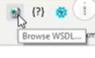

If you click it, you will have all the SOAP request that are available in this WSDL document.

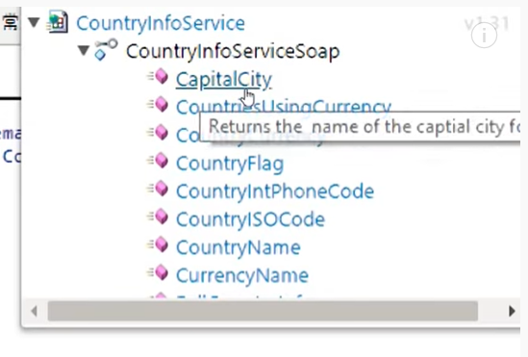

After clicking on any of these, you will have SOAP Message, I opened CapitalCity.

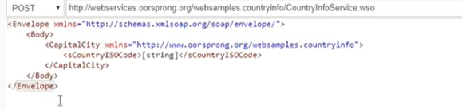

Step 5: Run and validate.

**How to chain API requests - Get data from response of one API and refer to another API**

Step1: Add our request in postman:

You have to create a request as you have learnt earlier, via sample APIs. You need to create 2, as we are making it in chain, so one request will work to produce result and give it to other to proceed further. In other words, one request will get results, transfer it to other request and second request will put it.

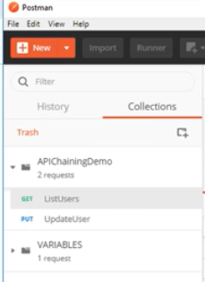

Step 2: Use environment variables to parameterize the value to be referred.

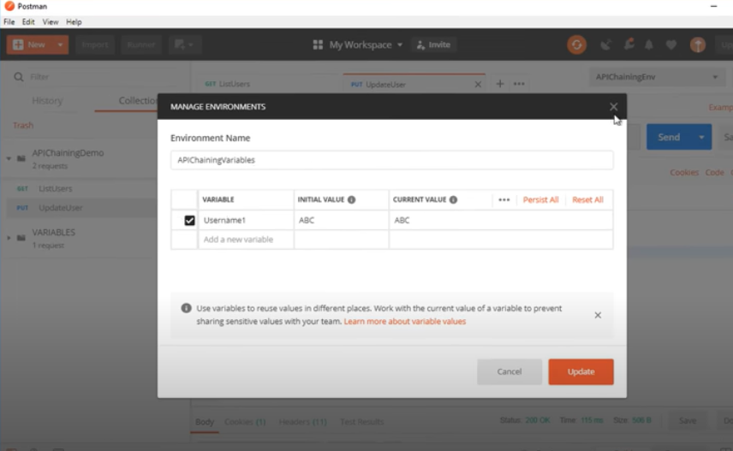

Step 3: Add scripts to fetch value from response of 1st API

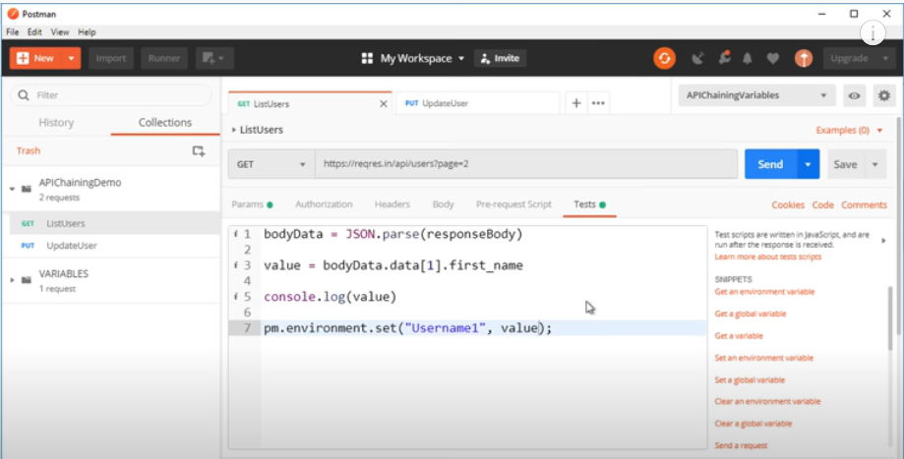

Step 4: Update the fetched value in environment variables.

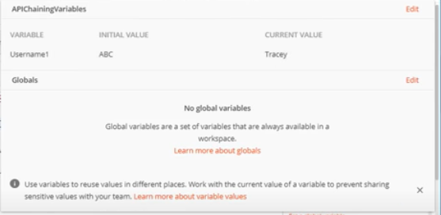

Run and validate.

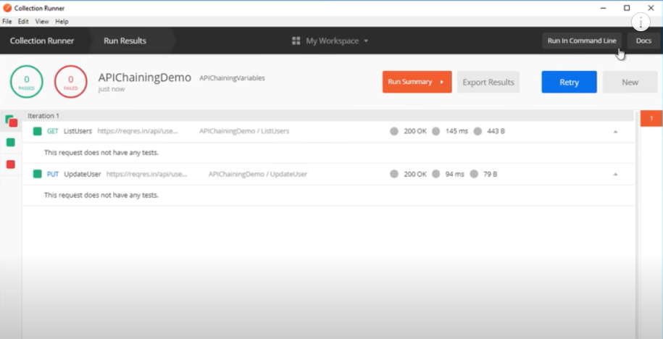

Reference: json path finder <http://jsonpathfinder.com> or go for json path finder “jsonPath finder” extension.